TO: West Virginia Licensed EMS Agencies

FROM: Jonathan Newman, MD, MMM, EMT-P, FACEP

State Medical Director for OEMS

(With thanks for Dr. Michael Mills and David O. Wright, MD)

DATE: March 30, 2022

RE: National Drug Shortage Critical Issue; Temporary Protocol Change 4604 Diabetic Emergencies

Due to the nationwide shortage unavailability of many concentrations of Dextrose, the following relief is offered to all licensed West Virginia EMS agencies. Check the FDA Drug Shortages webpage for companies that may have the concentrate of Dextrose that you may be running out of.

<https://www.accessdata.fda.gov/scripts/drugshortages/dsp_SearchResults.cfm>

Check your hospital that you transport to as they may be able to sell you the concentrate of dextrose that you need.

Protocols affected are the following:

4604 and 5604 Diabetic Emergencies

• Agencies with Dextrose 50W or 10W may continue to use the medications as directed by protocol until their stock is depleted.

• Agencies without D50W or D10W may use the modified protocol utilizing D5W, D10W, D20w, D30W. Pediatric patients require the D10W concentration. Make sure you understand the procedure to dilute the concentration of dextrose you will be needed before you use them.

• No formal/permanent change to State Protocols will occur at this time in anticipation of future D50W and D10W availability.

• This relief/directive will be effective starting 3/30/2022 and will continue for 92 days until 6/30/2022. If D50 and/or D10W are still unavailable, this directive will be reviewed and renewed.

• ALS vehicle equipment list will temporarily change the D50W and D10W requirement on class "C" ACLS vehicles to be optional with no required quantity for the 92 day extension.

• A MEMO outlining these changes will be forwarded to all Medical Command Facilities outlining these protocol treatment options.

WEST VIRGINIA OFFICE OF EMERGENCY MEDICAL SERVICES

EMERGENCY DIABETIC DIRECTIVE

The following directive is to be active only during times of National Medication Shortage or absence of D50W, D10W, D5W for the treatment of patients that are hypoglycemic. This directive will supplement ALS protocol 4604 (Diabetic Emergency) when all D50W, D10W, and D5W stock is depleted.

A. Perform INITIAL TREATMENT / UNIVERSAL PATIENT CARE.

1. Establish venous access. IV, preferably antecubital, with saline lock.

B. Assess level of consciousness and blood glucose level by glucometer.

C. Treat as indicated below. Substitute D5W with other concentrations of dextrose as needed to = 12.5g of dextrose: D10W = 125 ml, D20W = 62.5ml, D30W aprox. 42 ml

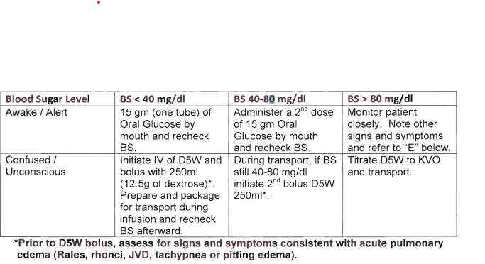

D. If IV dextrose is indicated above, but no IV available administer Glucagon 1.0 mg 1M.

E. If patient has signs or symptoms of diabetic ketoacidosis such as Kussmal respirations, acetone smell on the breath and or history of not taking insulin, and blood glucose level is > 80 mg/dl:

1. If no evidence of pulmonary edema or CHF administer 20mllkg normal saline IV then run at KVO.

Diabetic Emergencies Relief 4.30.22